**ODU’STECH INITIATIVE (OTI)**

Software engineering is the study of and practice of engineering to build, design, develop, maintain, and retire software. There are different areas of software engineering and it serves many functions throughout the application lifecycle.

Software engineering is a new era as CIOs and Digital Leaders now understand the importance of software engineering and the impact – both good and bad – it can have on your bottom line.

Vendors, IT staff, and even departments outside of IT need to be aware that software engineering is increasing in its impact – it is affecting almost all aspects of your daily business.

Software engineering is important because specific software is needed in almost every industry, in every business, and for every function. It becomes more important as time goes on – if something breaks within your application portfolio, a quick, efficient, and effective fix needs to happen as soon as possible.

## Future of Software Engineering

Software engineers are important and really the main importance of software engineering is that the build something that wasn’t there before. This is a unique field because they walk the fine line between creative and scientific. They need to be able to visualize the product and then create it.

Do you want to develop software for the needs of the users?

Do you want to develop software that runs devices and controls your networks?

Do you want software that does a combination of the two?

**DON’T KNOW WHERE TO START?**

The good place to start with are; HTML, CSS and JAVASCRIPT as a front end developer.

## **What is front end development?**

Front end development is the practice of making technology (products or websites) visually appealing and presented in an intuitive way.

### **What does a front end developer do?**

Put simply, a front end developer takes the functional code of a technology product (or website) and makes it appealing and accessible for humans.

## **What a front end developer works on**

Front end developers work on a wide variety of projects, all of which center around how a website looks and feels to end users.

### **Whole websites**

A brand’s website is the face it shows to the world. Front end developers are tasked with making these sites intuitive and attractive using HTML, CSS, and JavaScript.

**Types of software engineer**

* Video game designer.
* Quality assurance engineer.
* CRM project manager.
* Software integration engineer.
* Security engineer.
* **Front-end engineer.**
* **Full-stack engineer.**
* 3D Graphics Developer.

### **Is front end development easy?**

Becoming a successful front end developer has its challenges like any other career. However, many elements of the process are made easier because of increased access to resources online . Further, there are significant mentorship opportunities for front end developers through bootcamps, which helps make learning that much easier.

### **What’s the difference between a front end developer vs backend developer?**

A front end developer takes a piece of technology and designs the user side (as in: what clients or customers see). A back end developer, on the other hand, builds the core functionality and features of a piece of technology that is later made more accessible by the front end dev team.

## **Frameworks and programming languages front end developers use**

Front end developers use a wide range of programming languages and frameworks, many of which overlap with web design work. Here are the key languages and frameworks that all front end developers should think about learning.

### **HTML**

Hyper Text Markup Language (**[HTML](https://html.com/)**) is the standard markup language for web pages. HTML is how front end developers design and build the various elements on a page, for instance identifying header text or building sections of a web page. When you learn HTML, you’ll want to learn popular programming interfaces such as **[Document Object Model (DOM) interfaces](https://developer.mozilla.org/en-US/docs/Web/API/Document_Object_Model/Introduction)**.

### **CSS**

**[CSS](https://developer.mozilla.org/en-US/docs/Web/CSS)**—or Cascading Style Sheets—describes how HTML should look on a web page. These style elements can apply on a per-page basis or operate sitewide, for instance designing a header or footer. Building sitewide CSS is a common time-saving measure for front end devs.

### **JavaScript**

**[JavaScript](https://www.javascript.com/)** is a client-side programming language that allows you to build complicated or complex features on a website. Where HTML and CSS focus on how the site is displayed or looks, JavaScript looks more at how the site actually functions or what it can do. A part of learning JavaScript is also learning its major libraries such as **[jQuery](https://jquery.com/)**. JavaScript is also a full stack development language, meaning it can extend to both front end and back end development.

### **PHP**

Similar to JavaScript, **[PHP](https://www.php.net/)** allows developers to build complex functionality on a website. A key difference is that PHP is server side, meaning it generates HTML code that can be displayed on a website.

### **Python**

**[Python](https://www.python.org/)** is a general purpose programming language that works on all major operating systems. The code itself is built for readability, making it a bit easier to spot errors or issues with the codebase than other languages.

## **Characteristics of successful front end developers**

Here’s what you need to know about the types of people best suited to be a front end developer.

### **Who can become a front end developer?**

While developers in movies are commonly shown as young men, the reality is that any person—age, gender, race, or other characteristic—can become a front end developer. This is especially true now with the amount of resources available for front end developers.

### **Why would I want to be a front end developer?**

There are a lot of reasons why someone might want to become a front end developer:

* ****Money****: The job pays well and has strong career prospects.
* ****Challenge****: You get to work on a variety of interesting things.
* ****Impact****: Front end development work is seen by everyone who interacts with a brand.
* ****Progression****: Starting in front end development is a great way to start your career before expanding into multiple different technology roles.
* **Time:** you can be the manager of your time.

### **How long does it take to become a front end developer?**

You can learn the basics of front end development—and even get a junior front end developer job—in a matter of three months. Knowledge mastery takes significantly longer. Further, there is no official “done” point to front end development. The languages are always evolving and changing, so you’ll need ongoing professional development to keep your skills sharp.

### **Necessary soft skills**

Front end development isn’t just about coding. You also need these soft skills:

* ****Curiosity****: The landscape is constantly evolving—you have to want to keep learning.
* ****Grit****: There are a lot of tough days and hard challenges that you need to push through.
* ****Empathy****: You’re building the visual image of a brand. You need to think about how others will perceive it as you work.
* ****Problem-solving****: When a challenge hits, you need to know a few frameworks to break down the problem and eventually find a solution.
* ****Testing mindse****t: Front end developers run a lot of tests to see what works. You’ll need to embrace this mindset.
* ****Collaboration****: You’ll spend a lot of time collaborating either with colleagues or clients, depending on how you work and which organization you join.
* ****Prioritization****: There will always be things you don’t have time to fix. You need to know how to prioritize the most critical tasks - then accomplish them.

## **Front end developer career prospects**

There’s more to a job than what it pays. If you’re thinking about becoming a front end developer, you should also consider how the role progresses and what work opportunities open up in the future.

### **Do front end developers get paid well?**

Front end developers are typically paid very well and have great career prospects.

Front end developers in the United States earn an **[average salary](https://www.careerexplorer.com/careers/front-end-developer/salary/)** of around $50,000 per year, with the range going from around $40,000 for junior front end developers to $105,000 for more experienced front end devs.

It’s worth noting that many front end devs get paid more than this range. It depends on factors like years of experience, the specific company, and location.

If you choose to go freelance, you could earn more than these average salaries. According to CodeMentor, the **[average rate for a freelance front end developer](https://www.codementor.io/freelance-rates/front-end-developers)** is $61-80 per hour. To earn the average US salary, a freelancer would only have to work 16 hours per week.

### **Are front end developers paid less than back end developers?**

Back end developers tend to make slightly more than front end developers. In the **[United States](https://devskiller.com/back-end-developer-salary/" \l ":~:text=According to PayScale, the average,relatively low: $69,766 per year.&text=On the other hand, the,much higher: $96,468/year.)** the average back end developer salary can rise well into the six figures.

Freelancers, on the other hand, earn the **[same](https://arc.dev/hire-developers/back-end" \l ":~:text=Freelance Rates,-According to our&text=average hourly rate for back,$61 to $80 per hour.)**: the average is $61-80 per hour.

### **Career path for a front end developer**

Once you’ve mastered the skills of a front end developer, there are a lot of opportunities open to you.

****Specialization****: You can focus on one area of front end development, build deep subject matter expertise, and remain an individual contributor for years to come. This could involve a promotion to a senior front end developer role or switching companies to one that heavily leans on your skill set, thus giving you higher salary opportunities.

****Management****: If you like the coaching and planning element of front end development, you can move into leadership and management. You won’t code as often in this role, but you can scale your impact by leading teams.

****Consulting****: If you have deep subject matter expertise but don’t like the day-to-day coding element of front end development, you can move into a consulting role. As a consultant, you’ll be available to advise either more junior developers (if you’re an employee) or tech leadership clients (as a freelancer). While most consultants are typically freelancers or independent contractors, you can still do internal consulting as an employee.

****Founding a startup****: If you have an entrepreneurial mindset and think you have found a problem worth solving, use your front end development skills to build a tech startup. You may need to find a co-founder with additional skills depending on the scale of the project, but either way you can leverage your valuable skill set to work for yourself.

## **The seven step process to become a front end developer**

Becoming a front end developer is fairly straightforward. After learning relevant programming languages and getting your portfolio ready, it’s about finding the right opportunities and acing the pitch or interview. Here are some tips on how to successfully accomplish the seven necessary steps.

### **1. Learn front end programming languages**

Learning the various programming languages in front end development can be tricky. However, there are multiple different ways to build the skill set.

#### **Take a coding bootcamp course**

Coding bootcamps add value by providing a great deal of one-on-one interaction, coaching, and occasionally even career mentorship. They’re also usually quite fast (you complete them in a matter of months).

#### **Self-teach with online courses**

There are a lot of online courses for front end developers that can take you from zero to mastery (or to help you fine-tune your skill if you already have a foundation). Online courses tend to be relatively cheap compared to bootcamps or university programs. Sometimes they are even free. And you can work at your own pace, making it ideal if you’re building this skill set while working in another role.

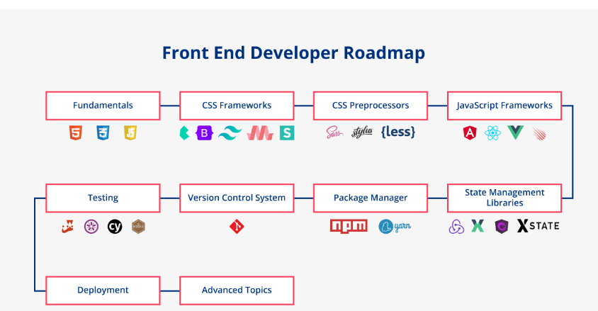

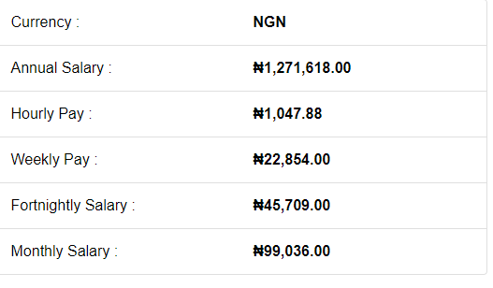

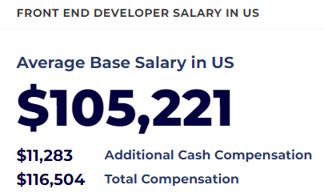

## **Front-end developer salary opportunities**

In an entry-level role, the average UK front-end developer salary starts at £31,000 and could increase to £65,000 with the right skills and experience. Experienced developer leads have an earning average of £96,000 and development managers could earn a salary of up to £100,000.

**QUETION: Are you to travel done to USA, UK before you can earn all this? The answer is NO! You can be in your room and be an employee in any nation of the world.**

**Are you seriouly looking for how to start? register with ODU’S TECCH INITIATIVE(OTI) for just 3months training and you will quench your hunger.**

**For more information;**

**Contact: 08165751228.**